The charts below give information on the location and types of dance classes young people in a town in Australia are currently attending.
Summarise the information by selecting and reporting the main features, and make comparisons where relevant.
Write at least 150 words.
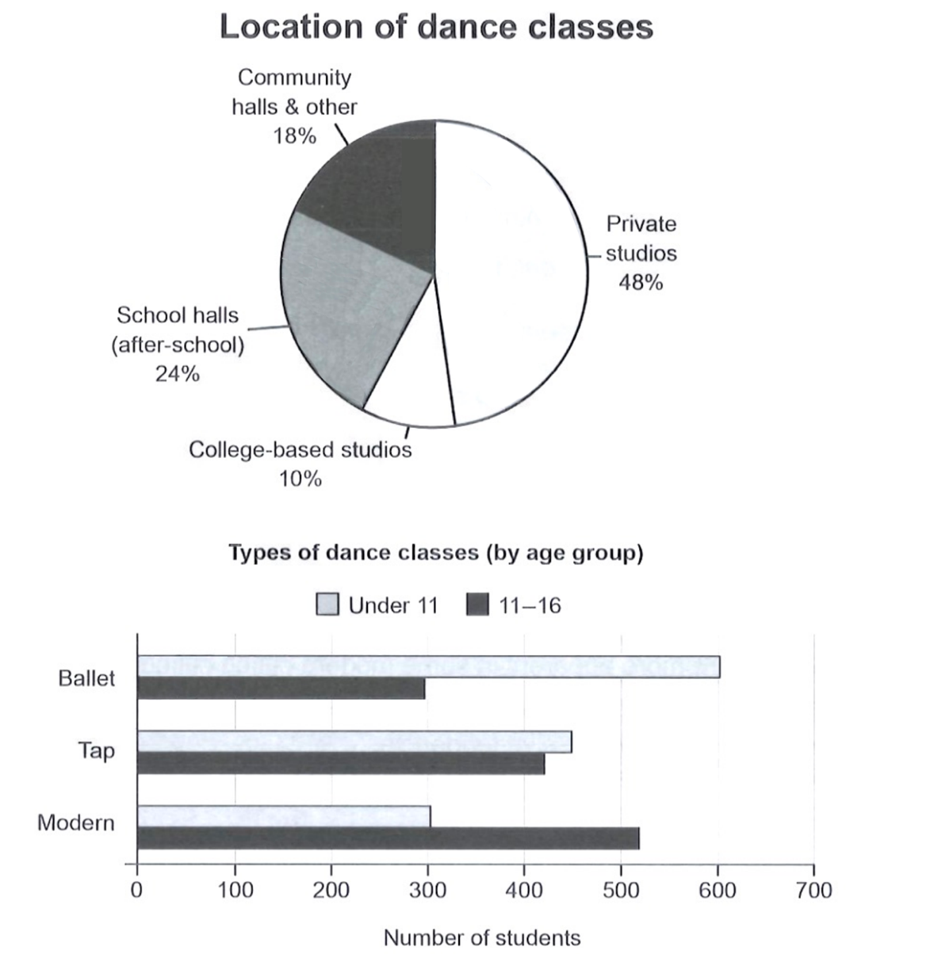
The pie chart illustrates the location of danced classes attending by young people in an Australian town and the bar chart shows the types of those classes.
The pie chart illustrates where young people in an Australian town attend dance classes, while the bar chart compares the numbers taking ballet, tap and modern classes by age group.

Overall, almost half of the young people attend dance classes in private studios and college-based studios are the least popular selection. Ballet classes are most popular among children under 11 and the least among 11-16 students. Tap dance classes have roughly the same number of attendants of both ages and modern dance classes attract the most children between 11 and 16.
Overall, private studios account for almost half of all dance-class locations, while college-based studios are the least common. Ballet is clearly the most popular option among under-11s but the least popular among 11-16-year-olds, whereas modern dance shows the opposite pattern and tap attracts similar numbers in both groups.

In terms of the location of dance classes, private studios are the most popular place, which have the proportion of 48%. College-based studios dance classes are the least popular among students, which are taken by only 10% of children. Dance classes in community halls and other places rank fourth among five locations, but still have the number of 18%, which it only a bit lower than the 24% of school halls (after-school).
For locations, private studios are by far the most common setting, accounting for 48% of classes. School halls are second, at 24%, exactly half the figure for private studios. Community halls and other venues make up 18%, while college-based studios represent the smallest share, at just 10%.

When it comes to the types of dance classes, the number of attendants under 11 of ballet classes is the most among all other types and ages, at about 600. Ballet is also the least popular type of dance among students from 11-16, at the figure around 300, which is closed to the number of children who attend the modern dance classes. Modern dance is the most attractive type of dance for children from 11-16, which have more than 500 students.
Looking at class types, ballet attracts about 600 under-11s, compared with only 300 students aged 11-16. The pattern is reversed for modern dance, with roughly 520 older students and 300 younger ones. Tap is more balanced, drawing around 450 under-11s and just over 400 11-16-year-olds.

Task Achievement: 7
Coherence & Cohesion: 7
Lexical Resource: 6.5
Grammatical Range & Accuracy: 6
Overall: 6.5
The answer identifies the main features and gives a clear overview, but the tap figures are not fully developed in the details and there is one inaccurate category statement.
The structure is logical, with separate paragraphs for the overview, locations and class types, although some linking is mechanical.
The main limit is language control: several phrases such as 'attendants', 'which have', 'have the number of' and 'is closed to' are unnatural or grammatically inaccurate.

To Reach Band 7 / 7.5
For a stable Band 7, keep the same clear overview and grouping, but remove small grammar errors in relative clauses, plural forms and data phrases.
Be precise with chart categories: 'community halls and other' is one category in the pie chart, and percentages should be described as shares or proportions.
To move toward 7.5, compress comparisons using 'whereas', 'compared with', 'respectively' and 'account for' so the answer sounds more natural and less repetitive.

The pie chart shows where young people in an Australian town attend dance classes, while the bar chart compares the numbers taking ballet, tap and modern classes in two age groups.

Overall, private studios are by far the most common location, whereas college-based studios account for the smallest share. In terms of class type, ballet is most popular among under-11s, while modern dance attracts the highest number of 11-16-year-olds; tap is comparatively balanced between the two groups.

Regarding location, almost half of the classes are held in private studios, at 48%. School halls are the second most common venue, accounting for 24%, which is exactly half the figure for private studios. Community halls and other venues make up 18%, while only 10% of classes take place in college-based studios.

For dance types, ballet has the largest number of younger students, with about 600 under-11s, compared with around 300 students aged 11-16. The opposite pattern can be seen in modern dance, which attracts roughly 520 older students but only 300 younger ones. Tap classes show a smaller age gap, with approximately 450 under-11s and just over 400 11-16-year-olds.
(198 words)

